The Curse of Immortality

Story Treatment

This story will show the tragedy behind the power of immortality. So often do we see villains or even heroes from different narratives try so hard to attain immortality for their own selfish (or selfless) desires. However, living forever can lead to an eternity of sorrow and suffering, and with this story, I want to show how it can degrade one’s mental and emotional state to the brink.
The story will start with darkness and void moving and turning until a bright light slowly engulfs the screen. While the light has some momentary discolorations indicating something is off (hinting at the immortality phenomenon), a new baby is brought into the world hearing one thing and one thing only: its own cries and his name, Wally. From there, the light will fade out into a new scene where the house and yard (main setting) is shown. The tone here will be hopeful and heartwarming as the birth of a new child is always a magical event. Starting out hopeful, the narrative will then start to slowly slow down and turn to a sad tone by the end.
After the birth of the Wally, we are brought into the inside of the house where we see a hallway of pictures. The POV will then focus on each picture, with some of them being animated to show a milestone in Wally’s life (Reaching Adolescence, Graduation, Marriage, etc.). Like walking through a progressive life gallery, the audience is shown the life of Wally up until the death of his wife Jessy. One thing that each of these pictures will show is how Wally doesn’t age compared to everyone else, making clear his difficult fate that will haunt him for the rest of his life. This section is meant to start of continuing the joyous tone of the first section and build it at first, but then as the gallery progresses, it will become more depressing and uneasy. Seeing Wally’s lack of aging will make it more uneasy when the realization of his long painful life ahead hits, and that is what the last section will capture.
In the last section of the story, the POV moves out showing a man holding the last picture of Wally and Jessy together. It is an old and withered Wally, still the same age as in the pictures but lacking the brightness he had in his eyes and the smile he used to share. After looking at the picture, he will look out the window, and the camera will slowly pan out to show the same house and old tree that lived through with Wally but under a cloud cover and withered. From there, the story will fade to black and conclude.
In the end, we will leave Wally to be forced to endure more years of sorrow, forced to watch generations of his family be born and pass and the world itself evolve further to who knows what. This will be a good cap to the narrative as it brings the idea of immortality leaving nothing but pain home.

Cast

Wally - 
Jessy –

Mom –
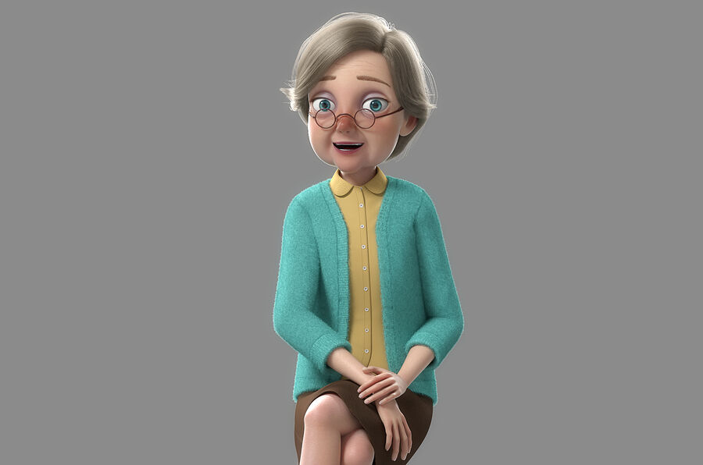
Dad –
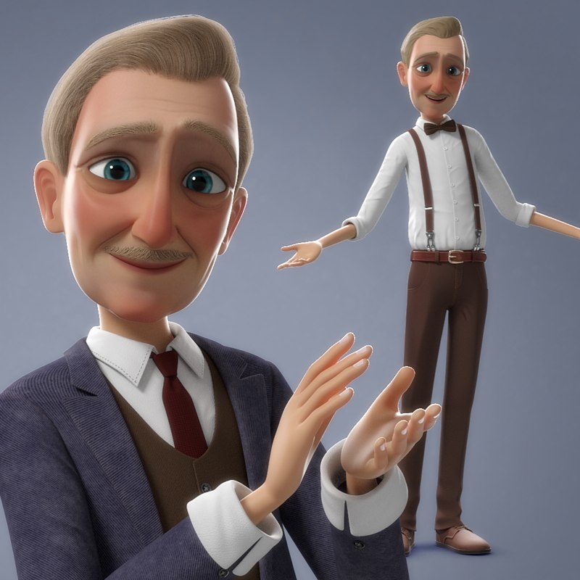

Concept Art

Main House with Tree
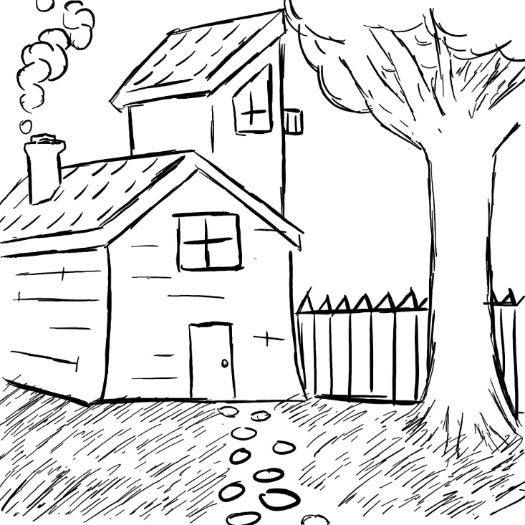
Hallway with Pictures
