11 Second Club Pitch
Scene: For the scene, I want to have the main character be on a stage, similar to a talk show stage, and have the spotlight shining down on him as he speaks. When he brings up his son, his son will pop up to his side for context, and when he brings up Walt Whitman’s quote on the wall, there will be a plaque on the wall to his side with a picture of Walt Whitman with the quote underneath.
Characters:
Speaker - 
Son –
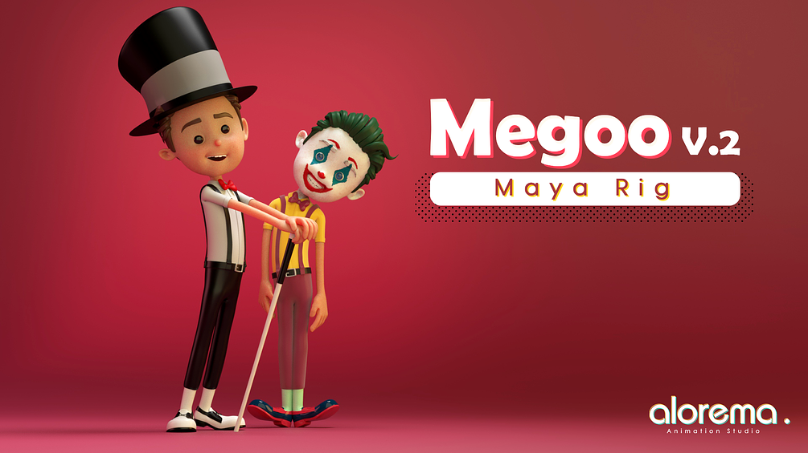

Stage Look:


