Aditya Oka
January 24, 2022

Together Now!

Story Treatment

Premise:
Hash, as ant sized man, is stuck on a chair and trying to climb up a table to reach an “egg” (some important object that I will specify later on). After some attempts to try and climb on his own, he comes to realize that he can’t do this alone. With his motivation and patience waning, Bin looks down from the table to see what the commotion is about. After a friendly greeting and a few gestures between each other, Bin agrees to help Hash climb up to the table with the help of different colored blocks. After a long and taxing few minutes of climbing, Hash finally reaches the top, but he notices the “egg” is gone. Looking behind him, he notices Bin walking away with the “egg”, and Hash runs after him as the scene fades to white.

Scene 1:
Hash is seen on the chair and eyes his target on top of the table (the “egg”).

Scene 2:
He tries to climb up on his own using and various climbing methods but fails every time. After multiple attempts, he stops, realizes he needs assistance, and sulks.

Scene 3:
Bin looks down from the table and sees the sulking Hash. Both exchange greetings and some gestures (Hash asking Bin for help to climb up), after which, Bin agrees to help Hash climb up.

Scene 4:
Bin drops different multicolored blocks to help Hash climb. After dropping ~5-6 blocks, Hash can climb and jump on top of the table.

Scene 5:
After giving thanks to Bin for his assistance, Hash goes to retrieve the “egg”, but notices that it is gone. Looking back at Bin, he notices that he is walking away carrying the “egg”. In desperation, he runs after Bin, and the animation fades to white.

Environment:
The setting will be a blank white room, like the landscape of the Mii app on the Wii. The chair and the Table will have a wooden material on it, while the multi-colored blocks will have a plastic texture to them. Finally, the “egg” will look shiny (like a gem) and be on a pedestal, showing how value and pretty it is.

Cast:

Hash:
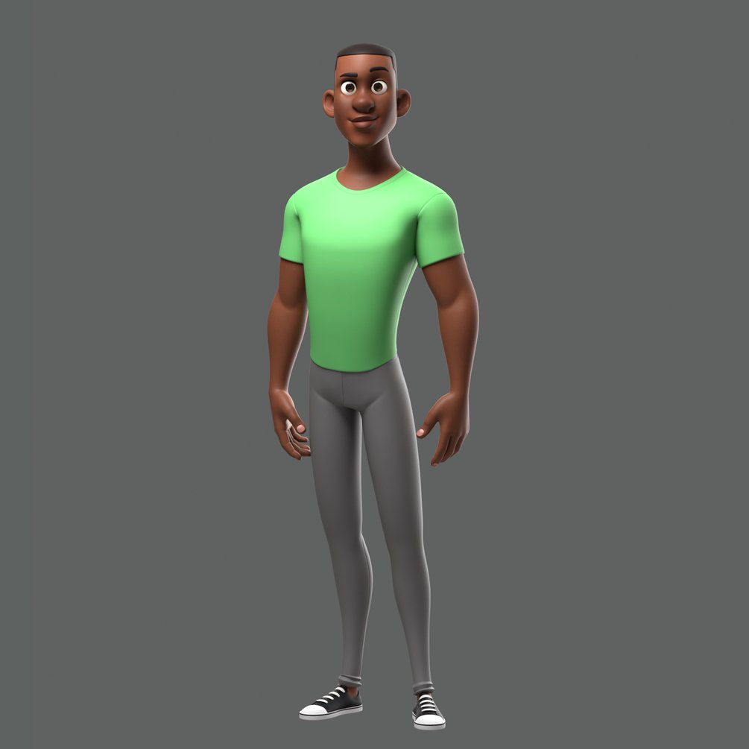
Bin:
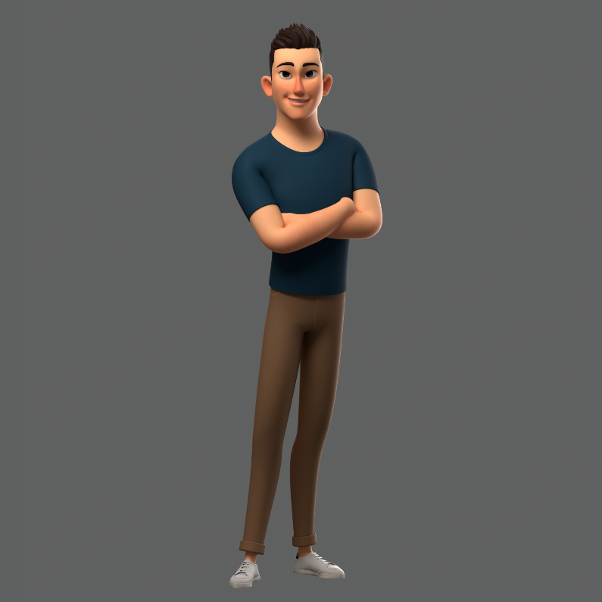

Concept Art

Main Room with Hash on the chair, Bin and multi-colored blocks on the table, and the “egg” on the pedestal:
